Bug Report

Summary

Bug ID | Test Case ID | Title | Priority | Severity | Assigned to
B01 | TC-070 | Send PATCH with excessively long input | Low | Low | hassan
B02 | TC-071 | Send PATCH with unsupported fields | High | Medium | hassan
B03 | TC-036 | Create booking with Firstname field empty. | High | High | Fadi
B04 | TC-037 | Create booking with total price as a String | High | High | Fadi
B05 | TC-038 | Create booking with check out date earlier than check in date | High | High | Fadi
B06 | TC-039 | Create booking with negative total price | High | High | Fadi
B07 | TC-040 | Create booking with non-existing check in/out dates | High | High | Fadi
B08 | TC-041 | Create booking with total price equals 0 | High | Low | Fadi
B09 | TC-051 | Update booking with total price negative value | High | High | Fadi
B10 | TC-053 | Update booking with first name (required field) empty. | High | High | Fadi
B11 | TC-054 | Update booking to make check out date earlier than the check in date | High | High | Fadi
B12 | TC-055 | Update check in date with string format. | Low | High | Fadi
B13 | TC-068 | Send PATCH with invalid data types | high | high | hassan

B01 API accepts excessively long input in firstname field without validation
Environment | Postman
Priority | Low
Severity | Low
Steps to Reproduce
- Select PATCH method
- Enter URL: https://restful-booker.herokuapp.com/booking/12
- Go to Body → raw → JSON
- Enter: {"firstname": "AAAAAAAAAAAAAAAAAAAAAAAAAAAAAAAAAAAAAAAAAAAAAAAAAAAAAAA..."}
- Click Send
Expected Result | API should reject excessively long input and return 400 Bad Request with validation message.
Actual Result | API returns 200 OK and accepts oversized value without validation.

Screenshots
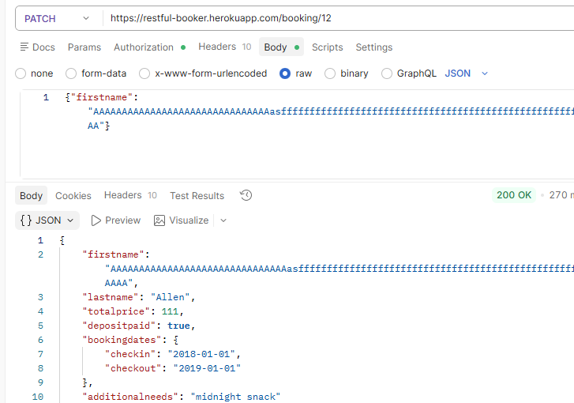

B02 API ignores unsupported fields instead of returning validation error
Environment | Postman
Priority | High
Severity | Medium
Steps to Reproduce
- Select PATCH method
- Enter URL:https://restful-booker.herokuapp.com/booking/12
- Go to Body → raw → JSON
- Enter:{"unknownfield": "value"}
- Click Send
Expected Result | API should reject unknown fields and return 400 Bad Request with error message.
Actual Result | API returns 200 OK and ignores the unknown field silently.
Screenshots
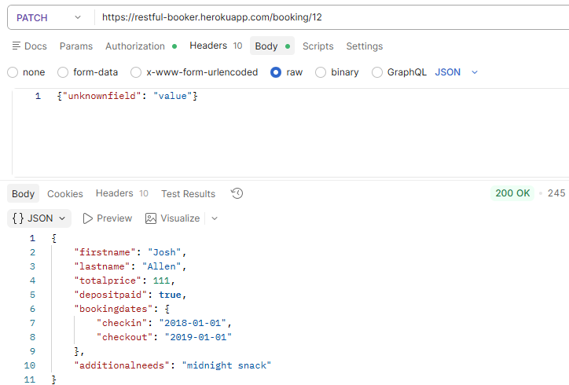

B03 Create booking with Firstname field empty
Environment | Postman
Priority | High
Severity | High
Steps to Reproduce
1. Make a POST request to {{base_url}}/booking.
2. fill in the JSON object with Test Data.
3. Click Send.
Expected Result | Bad Request 400, No booking is created.
Actual Result | Success 200, new booking is successfully created.
Screenshots
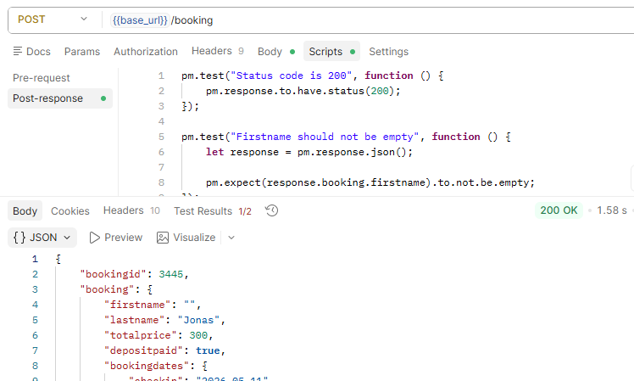

B04 Create booking with total price as a String
Environment | Postman
Priority | High
Severity | High
Steps to Reproduce
1. Make a POST request to {{base_url}}/booking.
2. fill in the JSON object with Test Data.
3. Click Send.
Expected Result | Bad Request 400, No booking is created.
Actual Result | Success 200, new booking is successfully created. It created a new booking with total price field: null
Screenshots
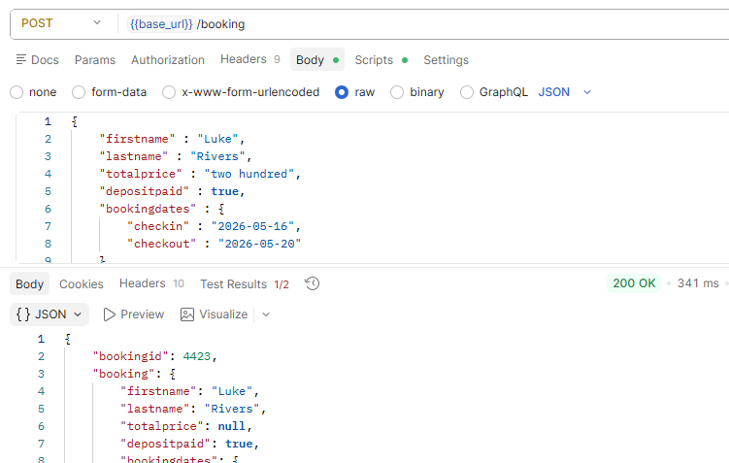

B05 Create booking with check out date earlier than check in date
Environment | Postman
Priority | High
Severity | High
Steps to Reproduce
1. Make a POST request to {{base_url}}/booking.
2. fill in the JSON object with Test Data.
3. Click Send.
Expected Result | Bad Request 400, No booking is created.
Actual Result | Success 200, new booking is successfully created.
Screenshots
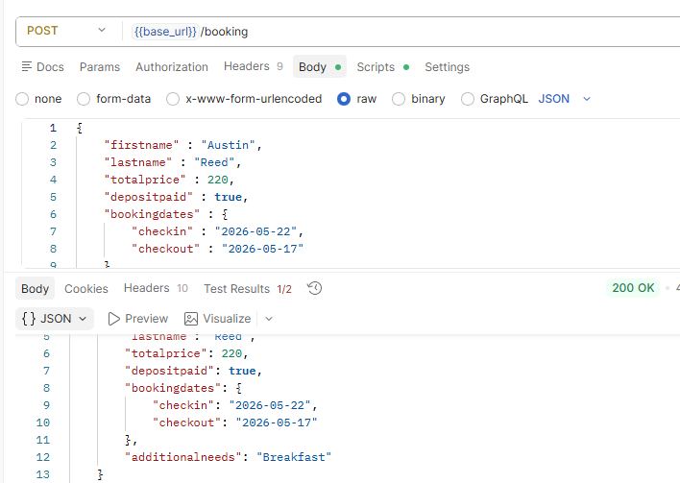

B06 Create booking with negative total price value
Environment | Postman
Priority | High
Severity | High
Steps to Reproduce
1. Make a POST request to {{base_url}}/booking.
2. fill in the JSON object with Test Data.
3. Click Send.
Expected Result | Bad Request 400, No booking is created.
Actual Result | Success 200, new booking is successfuly created.
Screenshots
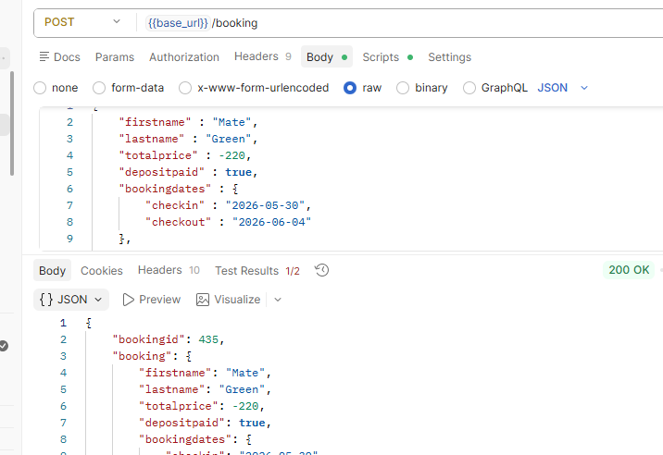

B07 Create booking with non-existing check in/out dates
Environment | Postman
Priority | High
Severity | High
Steps to Reproduce
1. Make a POST request to {{base_url}}/booking.
2. fill in the JSON object with Test Data.
3. Click Send.
Expected Result | Bad Request 400, No booking is created.
Actual Result | Success 200, new booking is successfuly created with check in/dates: 0NaN-aN-aN
Screenshots
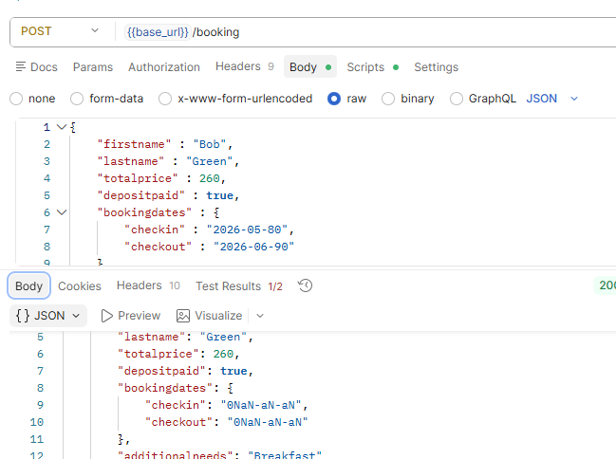

B08 Create booking with total price equals 0
Environment | Postman
Priority | High
Severity | Low
Steps to Reproduce
1. Make a POST request to {{base_url}}/booking.
2. fill in the JSON object with Test Data.
3. Click Send.
Expected Result | Bad Request 400, No booking is created.
Actual Result | Success 200, new booking is successfuly created with check in/dates: 0NaN-aN-aN
Screenshots
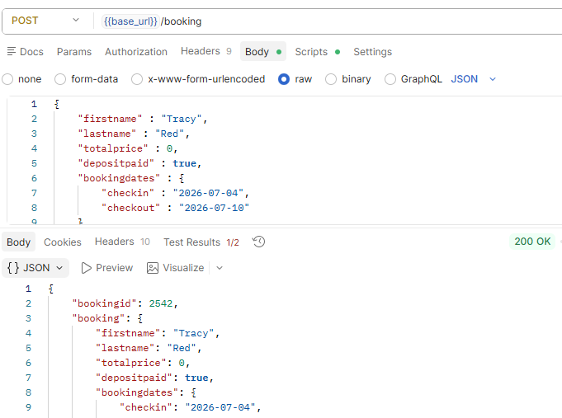

B09 Update booking with total price negative value
Environment | Postman
Priority | High
Severity | High
Steps to Reproduce
1. Make an update request on {{Base_url))/booking/:id.
2. Change the fields that are required to make the test case.
3. Click Send.
Expected Result | 404 Bad Request
Actual Result | Booking has been updated
Screenshots
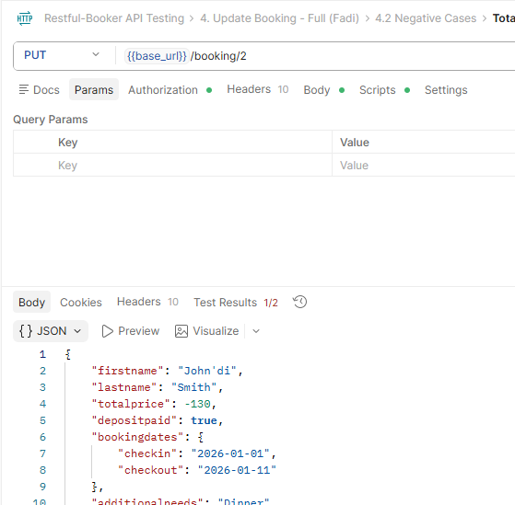

B10 Update booking with first name (required field) empty
Environment | Postman
Priority | High
Severity | High
Steps to Reproduce
1. Make an update request on {{Base_url))/booking/:id.
2. Change the fields that are required to make the test case.
3. Click Send.
Expected Result | Bad Request 400, No booking has been updated.
Actual Result | Booking has been updated
Screenshots
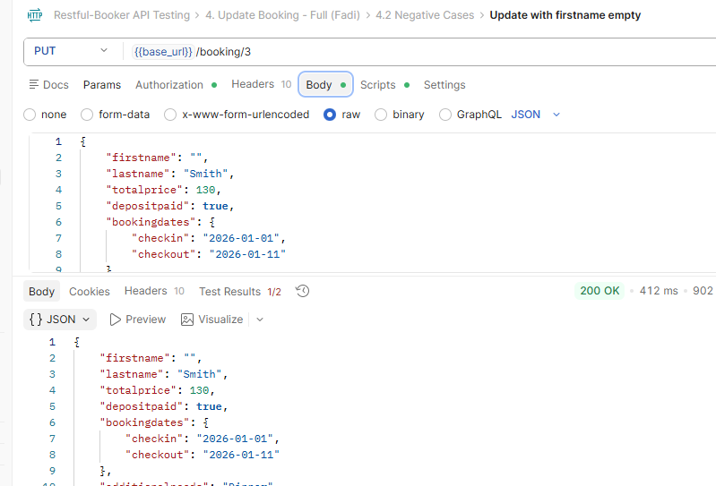

B11 Update booking to make check out date earlier than the check in date
Environment | Postman
Priority | High
Severity | High
Steps to Reproduce
1. Make an update request on {{Base_url))/booking/:id.
2. Change the fields that are required to make the test case.
3. Click Send.
Expected Result | Bad Request 400, No booking has been updated.
Actual Result | Booking has been updated
Screenshots
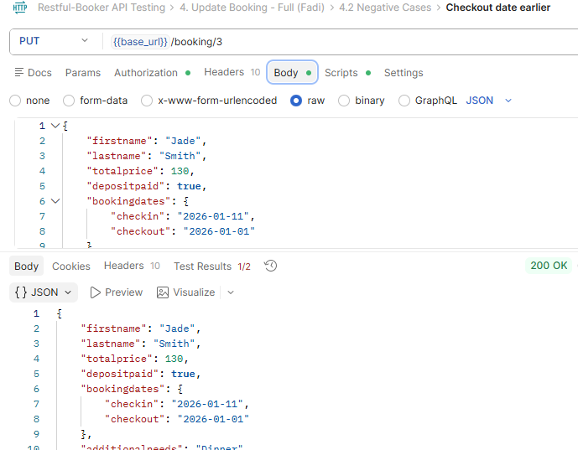

B12 Update check in date with string format.
Environment | Postman
Priority | Low
Severity | High
Steps to Reproduce
1. Make an update request on {{Base_url))/booking/:id.
2. Change the fields that are required to make the test case.
3. Click Send.
Expected Result | Bad Request 400, No booking has been updated.
Actual Result | Booking has been updated with check in date: "0NaN-aN-aN"
Screenshots
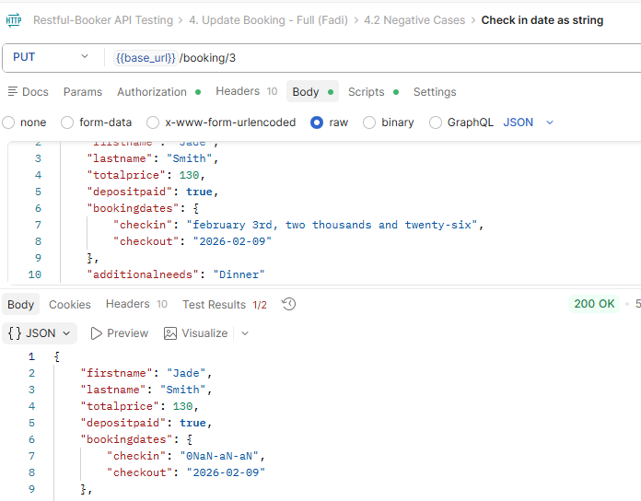

B13 Send PATCH with invalid data types
Environment | Postman
Priority | High
Severity | High
Steps to Reproduce
- Write string instead of integer in Body
- Click send
Expected Result | 405 Method Not Allowed
Actual Result | 200
Screenshots


